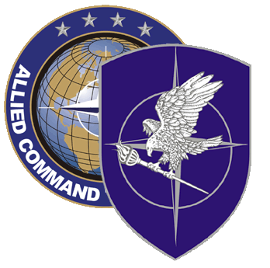
NATO SCHOOL: Global Leader in Multinational Military Education and Individual Training

M3-116 SMALL Arms AND LIGHT WEAPONS (sALW) AND MINE ACTION (MA) course

The aim of this course is to provide students with an important introductory but comprehensive overview of the most significant substantive, political, practical and regulatory issues that will be encountered when dealing with the topics of SALW and mine action from a national, regional or global perspective. Students should leave this course having gained a good understanding of the problems posed by these two issues; the current regional and international efforts in place to tackle these issues; the players involved in such efforts and their respective roles; relevant best practices and agreements; and finally, students should have gained a level of understanding which will give them insights into how SALW and MA projects are designed, developed and implemented

Course Length: 1 week

Offerings per year: 1

Class Size: Max 30 / Min 15

Security Clearance: NATO UNCLASSIFIED

Rank Limitation: None

Prerequisites: Language proficiency: English IAW STANAG 6001 3333

Course Objectives:

At course completion, the student should be able to:
- (Coming soon)

